Лаба 20

Задание 1

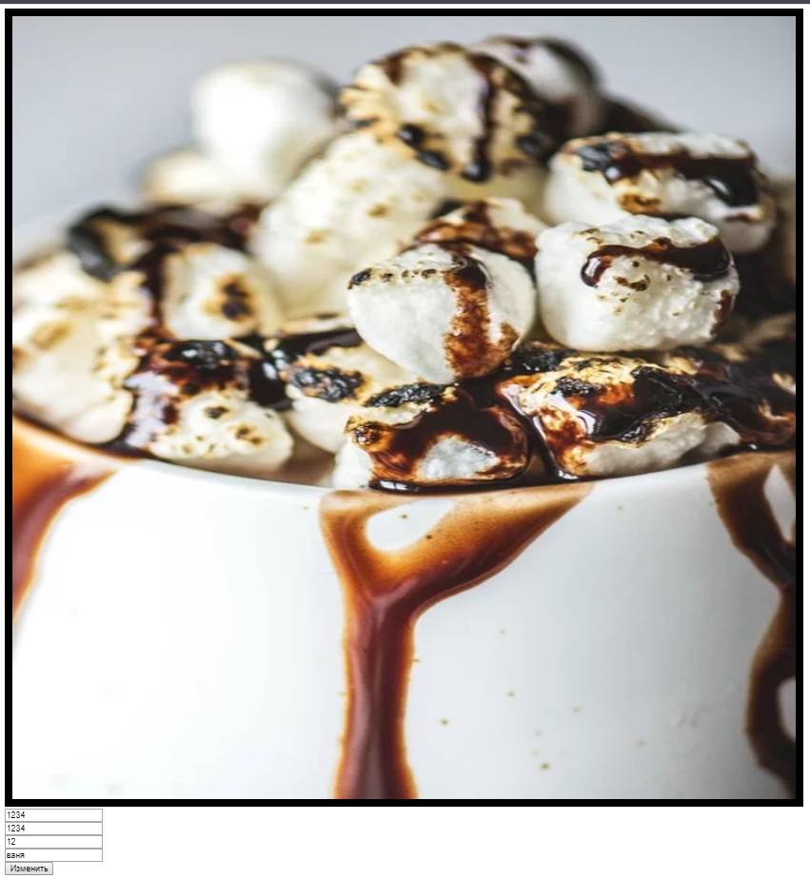

<!DOCTYPE html>

<html lang="en">

<head>

  <meta charset="UTF-8">

  <meta name="viewport" content="width=device-width, initial-scale=1.0">

  <meta http-equiv="X-UA-Compatible" content="ie=edge">

  <title>Document</title>

</head>

<body>

  <img id="image" width="150" height="150" src="https://cdn.pixabay.com/photo/2019/02/28/10/28/beverage-4025703_960_720.jpg"><br>

  <form name="form">

    <input name="width" placeholder="ширина"><br>

    <input name="height" placeholder="высота"><br>

    <input name="border" placeholder="рамка"><br>

    <input name="alt" placeholder="aльтернативынй текст"><br>

    <button onclick="set()">Изменить</button>

  </form>

  <script src="script.js"></script>

</body>

</html>

const image = document.getElementById('image');

function set() {

  event.preventDefault();

  image.width = document.form.width.value;

  image.height = document.form.height.value;

  image.border = document.form.border.value;

  image.alt = document.form.alt.value;

}

Задание 2

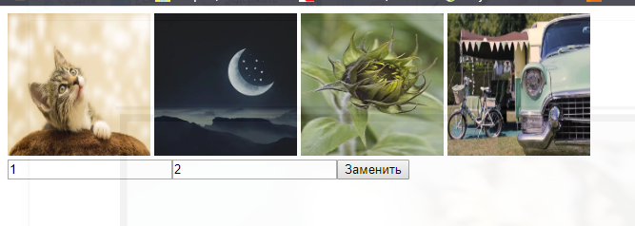

<!DOCTYPE html>

<html lang="en">

<head>

  <meta charset="UTF-8">

  <meta name="viewport" content="width=device-width, initial-scale=1.0">

  <meta http-equiv="X-UA-Compatible" content="ie=edge">

  <title>Document</title>

</head>

<body>

  <img name="image" src="https://cdn.pixabay.com/photo/2019/11/06/14/33/moon-4606246__340.jpg" width="150" height="150">

  <img name="image" src="https://cdn.pixabay.com/photo/2019/11/08/11/56/cat-4611189__340.jpg" width="150" height="150">

  <img name="image" src="https://cdn.pixabay.com/photo/2019/11/12/14/51/sunflower-4621224__340.jpg" width="150" height="150">

  <img name="image" src="https://cdn.pixabay.com/photo/2019/11/07/22/42/camping-4610085__340.jpg" width="150" height="150"><br>

  <input name="input"><input name="input"><button onclick="set()">Заменить</button>

  <script src="script.js"></script>

</body>

</html>

const images = document.getElementsByName('image');

const inputs = document.getElementsByName('input');

function set() {

  if (!(inputs[0].value < 1 || inputs[0].value > 4 || inputs[1].value < 1 || inputs[1].value > 4)) {

    const bufer = images[inputs[0].value - 1].src;

    images[inputs[0].value - 1].src = images[inputs[1].value - 1].src;

    images[inputs[1].value - 1].src = bufer;

  }

}